**P3C3 - HR Analyst - Manager Analysis**

You are currently employed by the HR department. Congratulations!

 Your boss thought your previous work was exactly what she needed.  
  
Recently, several employees have been complaining to the HR team about a manager who is responsible for the production department--Webster Butler. Before your boss talks with Webster's boss, she wants you to analyze some data to see if it supports the complaints against him. Your data analysis should complete the tasks listed below plus anything else you feel is relevant:  
  
Figure out which managers have the most employees that have quit. (In order to do this, take a minute with your teacher to review quick measures and filtered values.) If one manager has 20 people with 6 that have quit, while another manager has 10 people with 4 that have quit, which one has "more" employees quitting? Create a bar chart that shows the 3 worst managers based upon the "quit" ratio of their team members.  
Using a different field, identify the top 5 managers based upon the performance of their employees. Then, look at the data to see if you can quantify this field to create a comprehensive score for each manager. Create one or more visuals to display your findings.  
Practice using the Q&A feature with your new measurements to create additional visuals.

Notice how Power BI allows you to use these new measurements within the Q&A.  
Prepare a Power BI presentation that can be taken to Webster's boss in case it is needed. Make sure that you apply the Pyramid Principle. That means your first page should summarize your findings with supporting evidence found on the remaining pages.

**DATA ANALYSIS AND VISUALIZATION IN POWER BI**

**Introduction**

The field of data analysis and visualization has seen immense growth in recent years, with the increasing demand for insights and decision-making based on data. Power BI, a powerful data visualization tool developed by Microsoft, has been a game-changer in this field, providing a comprehensive solution for data analysis and visualization.

This project is an exploration of Power BI's capabilities in analyzing and visualizing HR data, with a focus on employee performance and turnover. The project will use Power BI's quick measures, filtered values, and custom visuals to analyze the data and provide insights.

**Preparation:**

* Load the necessary data into Power BI
* Check the data and make sure it is properly formatted and cleaned.
* Create relationships between the tables if necessary.
* Answering questions

**Brief**

The dataset I was analyzing had 19 columns and a total of 301 rows which would be equivalent to the total number of employees. I looked at relevant columns for this project which included Manager Name, Employee Source, Employee Status,department and Performance Score.

To begin the project, I utilized Power BI's features by creating a table “New Measures” to store my calculated measures. To create a table, follow these steps;

1. Go to the Home Tab and select “Enter Data”
2. Rename your table in the new window that pops up and press Enter

To create a New Measure;

1. Right click on your new table and select new measure
2. Type a name for the new measure and write a DAX formula that defines the calculation you want to perform
3. Press Enter to create new measure

Then I performed EDA on employees and their respective departments. Looking at total employees, male and female by department and created new calculated measures for total number of employees, male and female employees displaying their percentages.

**Code Snippets;**

Total Number of Employees

Total Employees = COUNTROWS(Core_Data)

Core_Data is the name of the table we are looking at where as the function COUNTROWS counts all the rows available in the table.

**Total of Male Employees and Percentages;**

Male = CALCULATE(COUNTROWS(Core_Data), Core_Data[Sex] = "Male")

The above DAX formula counts all rows in our table and filters out Male employees from the Sex column.

Male Percentage = DIVIDE([Male], [Total Employees]) * 100

In the above DAX formula we divided the total of male employees by the total number of employees and multiplied the result by 100.

We do the same to attain the same results for the female employees. This is how it looks like;

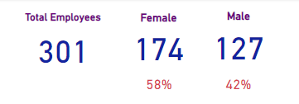

I also looked at the distribution of total employees male and female by department. Their were six departments in total and this is how the employee – department report looked like;

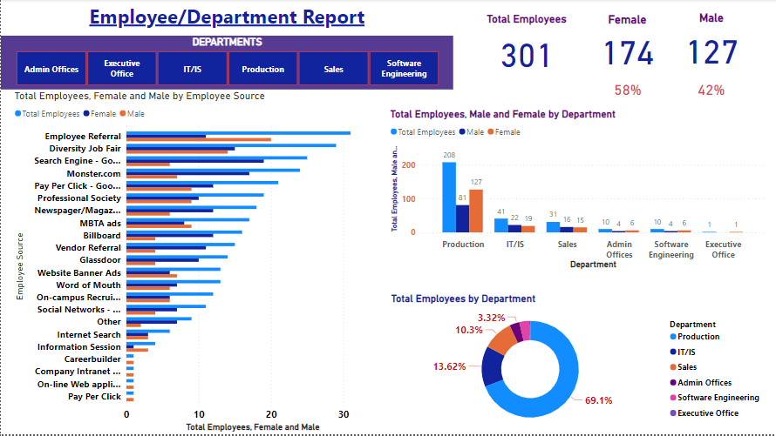

**QUESTION 1**

**Find managers with the most employees that have quit:**

Create a calculated measure to determine the number of employees who have quit for each manager.

To do this, I created a calculated measure “Voluntarily Terminated” using the DAX formula below:

Voluntarily Terminated =

CALCULATE(

    COUNTA('Core_Data'[Employment Status]),

    'Core_Data'[Employment Status] IN { "Voluntarily Terminated" }

)

The above DAX formula uses the "CALCULATE" function to count the number of occurrences of the "Employment Status" column in the "Core_Data" table where the value is "Voluntarily Terminated". The "COUNTA" function counts the number of non-empty values in the "Employment Status" column. The "IN" operator is used to specify the criteria for the calculation, which is to count only the rows where the "Employment Status" column value is "Voluntarily Terminated. The visual looks like this;

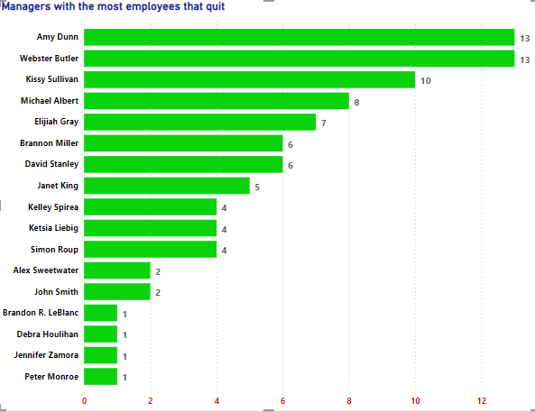

**Create a calculated column to determine the total number of employees for each manager.**

I created a calculated measure using a DAX formula below:

Manager Employee Count = SUMX(

  GROUPBY(

    Core_Data,

    Core_Data[Manager Name],

    Core_Data[Employment Status]

  ),

  CALCULATE(

    COUNT(Core_Data[Employment Status]),

    Core_Data[Employment Status] = EARLIER(Core_Data[Employment Status])

  )

)

The DAX formula above calculates the total number of employees managed by each manager. It uses the “SUMX” function to sum the results of the calculation for each unique group of Manager Name and Employment.

The groupby function groups the rows in the table "Core_Data" based on Manager Name and Employment. Within the sumx function, the calculate function is used to count the number of employment statuses for each group and the result of this calculation is summed for all groups. The EARLIER function references the current value of Employment within the group.

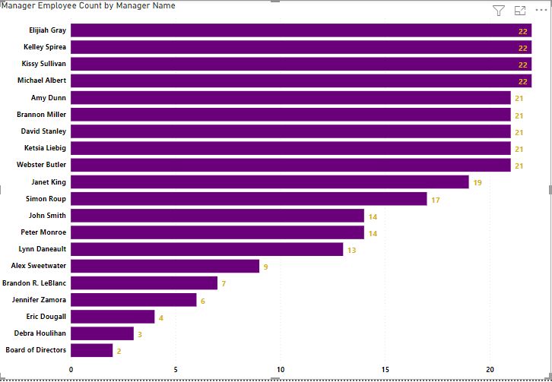

**Create a calculated column to determine the top 10 managers with the highest quit ratio.**

To do this, I created a calculated measure using the DAX formula below to generate the quit ratio from the Voluntarily Terminated calculated Measure:

Quit Ratio = DIVIDE([Voluntarily Terminated], [Manager Employee Count])

The "Voluntarily Terminated" field calculates the number of employees with the employment status of "Voluntarily Terminated". The "Manager Employee Count" field calculates the total number of employees for each manager and their employment status. The final result of the "Quit Ratio" field is the ratio of employees who voluntarily terminated their employment to the total number of employees managed by each manager.

The Visual bar chart looks like this;

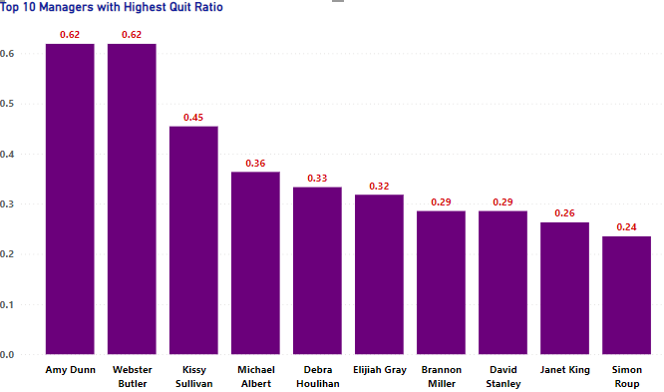

**Identifying the top 5 managers based on employee performance:**

To identify the top 5 managers based on employee performance, I had to encode or quantify the Performance Score column whose values were in text format by creating a calculated column “Quantified Score”.

To Quantify the performance score field I used the DAX formula below;

Quantified Score = SWITCH([Performance Score],

"90-day meets", 10,

"exceeds", 30,

"exceptional", 50,

"fully meets", 20,

"Needs improvement", 5,

"PIP", 1,0)

The DAX formula above defines a calculated column named "Quantified Score". This column converts the "Performance Score" text values into numerical values by using the SWITCH function. The SWITCH function takes in the "Performance Score" as the first argument, followed by pairs of values and their corresponding numerical values.

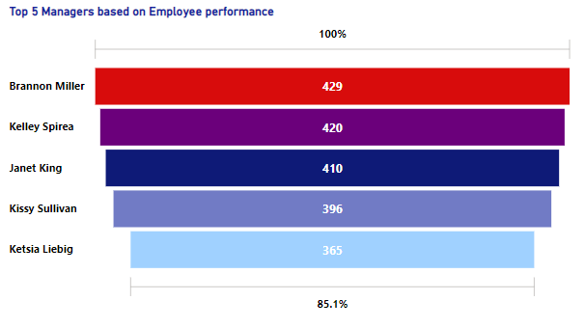

In conclusion, this project aimed to explore the capabilities of Power BI in analyzing and visualizing HR data. Through the use of various Power BI features such as quick measures, filtered values, and custom visuals, meaningful insights were drawn from the data provided. The project focused on employee performance and turnover and analyzed the data to determine the managers with the most employees quitting and the top 5 managers based on employee performance. The results were presented using bar charts and tables, and the custom visuals created were used to help in the decision-making process. The use of Power BI in data analysis and visualization has proven to be an effective solution, providing a comprehensive way of analyzing data and presenting the results in an easy-to-understand format.